Exam 1

* Core highest in Si and lowest in Fe and Mg: Continental
* Cascades examples of Volcanic arc
* Fe – most abundant element on earth
* 1960s – highest growth rate of global population in human history
* Pyrite (FeS2) is in the sulfide mineral class
* Hematite (Fe2O3) is in the hematite class
* Sulfides contribute to acid mine damage
* Minerals form from precipitation of fluids, solidification of melts, and biomineralization
* 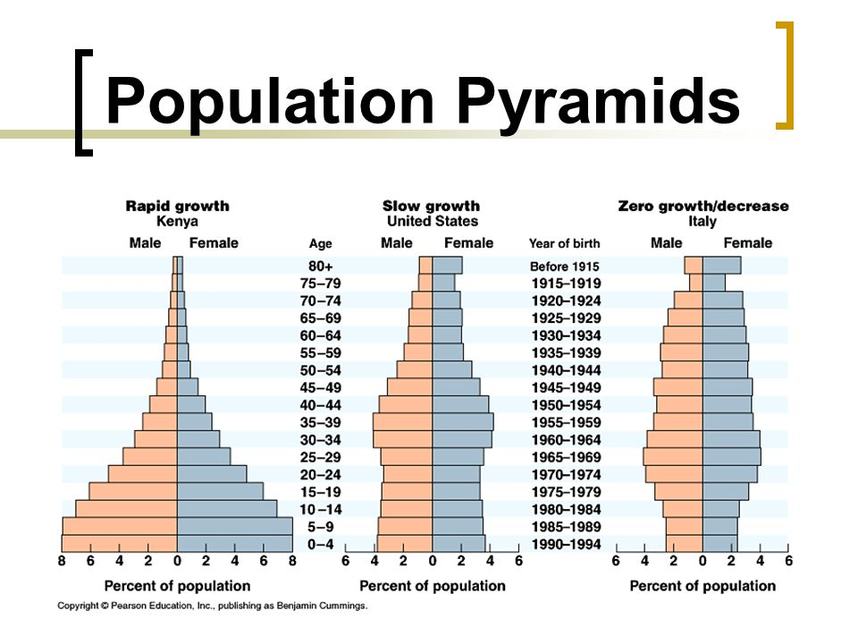Course grained igneous from slowly cooled magma
* Porphyry-type deposits (Cu and Mo) are metal rich fluids sourced from silica rich igneous intrusions in subduction zones
* Kimberlite is formed when magma deep in mantle bearing high pressure minerals rising rapidly to surface erupting explosively
* Laterite:
  + Aluminum, nickel, iron
  + Long lasting chemical weathering of parent rock
  + Tropical areas
* Evaporite:
  + Sodium, gypsum, borates
  + Iron saturated water evaporates, condensing into evaporate
  + Shallow basins
* Placer
  + Golds, silver, titanium, diamonds
  + Heavier minerals snowball into large deposits
  + Streams and shores with heavy wind and rain
* Banded Iron Formation
  + Iron, quartz
  + Sissolved iron oxygenizes, results in some layers precipitation
  + Ocean depths near volcano settings
* Layer igneous intrusion
  + Iron, chromium, titanium, nickel, platinum-group elements
  + Magma cools before it reaches surface
  + Hot spots
* Volcanogenic massilve sulfide
  + Nickel and cobalt, iron, copper, silver, mercury, gold manganese
  + Hydrothermal flud erupts into sea and quickly cools (black smokers)
  + Mid ocean ridge
* Kimberlite
  + Diamonds
  + Colling after sub surface magma explodes
  + Extremely hot temperatures deep within mantle
* Pegmatite:
  + Aluminum, tin, tantalum
  + End stage of magma crystallization, edge of batholits

Exam 2

* Industrial revolution did not decrease pollution in rural areas
* Consumption on renewable resources decreased in 20th century
* Abundant metals = > .1% of weight of crust
* US steel and car industries built in midwest because of proximity to banded iron formations, coal deposits, and limestone deposites – NOT forests
* Scarce metals present in very low abundances in many common minerals due to atomic substitution
* Mountaintop removal mining common for coal
* Long wall mining: underground coal mining method that allows recovery of as most 90% of coal at risk of subsidence
* Hydraulic mining: Method devastating to riparian habits and can clog rivers and bays with silt
* Wetter climate increases restortation but increases risk of acid mine damage
* Surface mining control and reclamation act of 1977 required mine lands restored to pre-mining conditions
* Reclamation of underground mines not more difficult than open pit mines
* OPEC formed in response to oil companies decreasing oil prices
* Strageic reserves determined in relation to importance to military and political stability of primary importing nations
* Smelting:: Process of separating metal from metal bearing minerals
* 1992: Year mine reclamation act was amended to require companies to post 100% of clean up costs upon starting new mining venture
* Tungsten: Highest melting temperature and highest tensile strength of all metals
* Copper: Malleability and electrical conductivity make it useful wiring. Not silicon.
* Mining pollution and degradation persistent across US today despite well-enforced regulation because:
  + Legacy mines, abandoned before regulations put in place
  + Impacts of abandoned mines are persistent

Exam 3:

* Western coal deposites are lower grade and lower in sulfure than eastern deposits
* US coal deposites expected to last 225 years
* The last 100 years, precipation has been decreasing

After:

Glacial period

* Ice has less heavy oxygen, oceans have lots of heavy oxygen

Nuclear disasters:

* 1979: Three Mile Island, no casualties, canceled every planned plant in US
* 1986: Chernobyl, 100,000s irrated
* 2011: Fukushima: Caused by tsunami

Nuclear energy

* 20% of global energy, 18% of US
* Radiation: Disintegration of unstable elements
* Fission: Splitting
  + What we do
* Fusion: Combining